**DAY 08**

**27.06.2023**

**Neural Networks**

The structure and operation of the human brain served as the inspiration for the class of machine learning models known as neural networks. They are computer models made up of layers of interconnected nodes called neurons. Each neuron takes in information, processes it, and then emits an output.

The artificial neuron, often known as a perceptron, is the fundamental unit of a neural network. An input layer, one or more hidden layers, and an output layer make up a neural network's usual organisational structure.

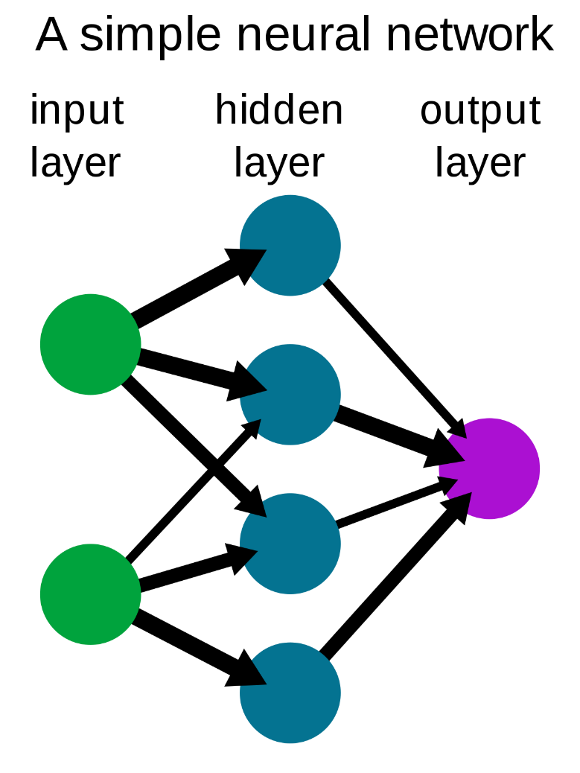

The network passes the raw input data from the input layer to the output layer, which generates the finished product. The network may learn hierarchical representations of the data thanks to the hidden layers, which are situated in between the input and output layers and carry out intermediate calculations.

**Convolutional Neural Networks**

Convolutional Neural Networks (CNNs) are a particular class of deep learning algorithm made for processing and analysing structured grid-like input, including photos and videos. Computer vision tasks have been transformed by CNNs, which achieve cutting-edge performance in a variety of applications, including picture classification, object identification, image segmentation, and more.

Convolution is a mathematical procedure that combines two functions to create a third, and it is this mathematical activity that forms the basis of CNNs.

Convolutions are employed in the context of CNNs to extract useful features from input data by applying filters or kernels to small input regions. A feature map that highlights pertinent patterns or features is created by these filters, which are tiny matrices that are convolved with the input to produce dot products.

Here are some significant CNN-related elements and ideas:

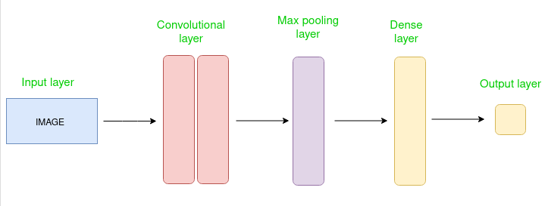



***Convolutional layers:*** These layers are made up of numerous trainable filters that slide over the input data to produce feature maps by performing convolutions. Each filter catches particular patterns at various spatial places, such as edges, textures, or forms.

***Pooling layers:*** These layers try to reduce the computational complexity and extract the most important features by reducing the spatial dimensions of the feature maps. A frequent strategy is max pooling, where the highest value inside a pooling window is chosen as the representative value.

***Activation functions:*** ReLU (Rectified Linear Unit) activation functions are frequently used in CNNs to inject non-linearities into the network and enable it to learn intricate correlations between features.

***Fully connected layers:*** At the network's conclusion, fully connected layers are frequently employed to link the high-level features that the prior layers had extracted to the desired output, such as class probabilities in image classification.

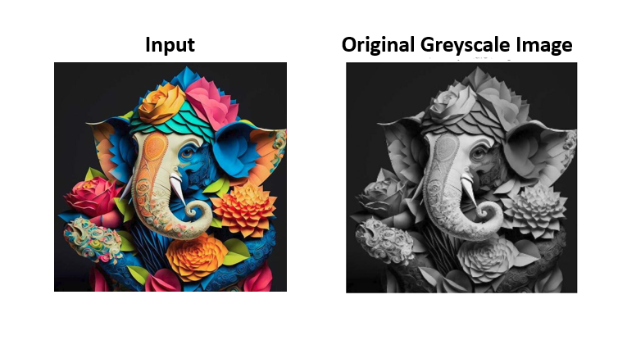

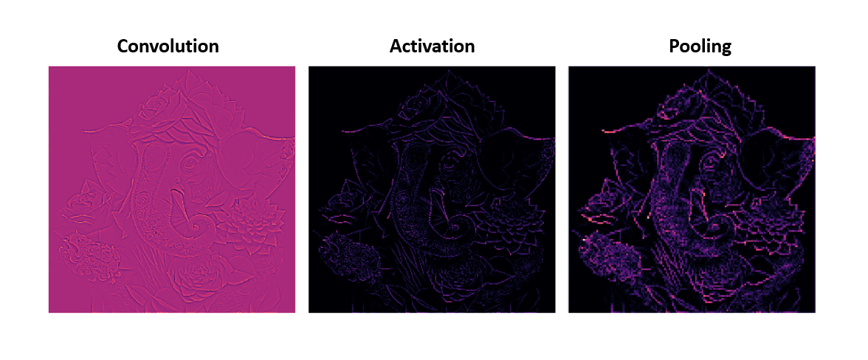

***Training:*** Backpropagation is a technique used to train CNNs using a sizable labelled dataset. Using optimisation algorithms like stochastic gradient descent (SGD), the network learns to modify its internal parameters (weights and biases) during training in order to minimise a predetermined loss function.

***Transfer learning:*** When pre-trained models that have been trained on substantial datasets are employed as the foundation for new tasks, CNNs can benefit. One can successfully train a CNN on smaller datasets or various tasks by using the learnt representations from the pre-trained network.

***CNN Architecture***

* VGG
* Xception
* ResNet
* DenseNet
* InceptionV3
* InceptionResnet
* MobileNet
* NasNet
* EfficientNet
* ConvNeXt

***Applications***

* Image Classification
* Object Detection
* Sematic Segmentation
* Image Generation
* Video Analysis

**References**

<https://www.ibm.com/topics/neural-networks>

<https://news.mit.edu/2017/explained-neural-networks-deep-learning-0414>

<https://www.ibm.com/topics/convolutional-neural-networks>

<https://www.geeksforgeeks.org/introduction-convolution-neural-network/>